To add Chart String Billing Account to Profile
Log into Fisher website then click on your name in the header tool bar

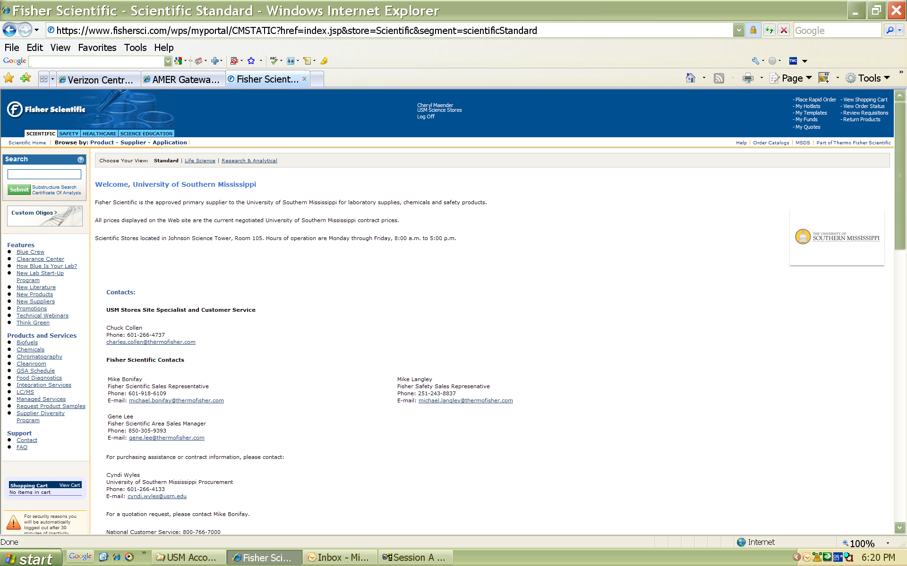

Click to Request New Account
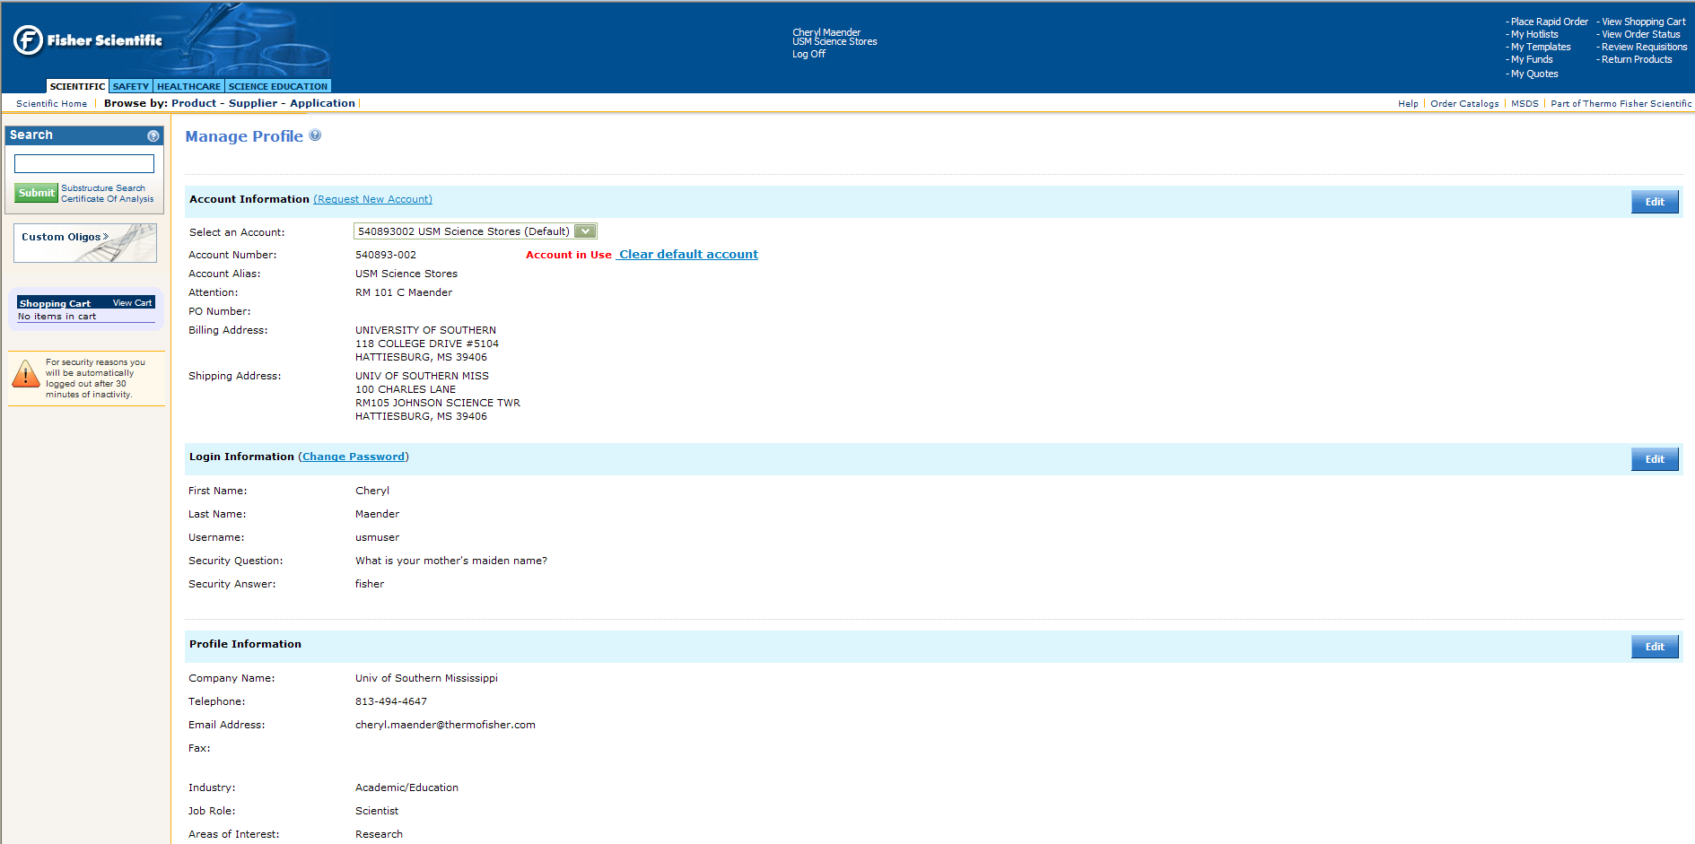

Add Fisher Chart String Account Number Based on the following:
540893-005 Dean’s Office
540893-003 Biological Sciences
540893-004 Chemistry & Biochemistry
540893-010 School of Criminal Justice
540893-005 Geography & Geology
540893-007 Polymers and High Performance Material
540893-008 Medical Technology
540893-009 Gulf Coast

Suggest naming your Alias Chart String Account or Storeroom Account

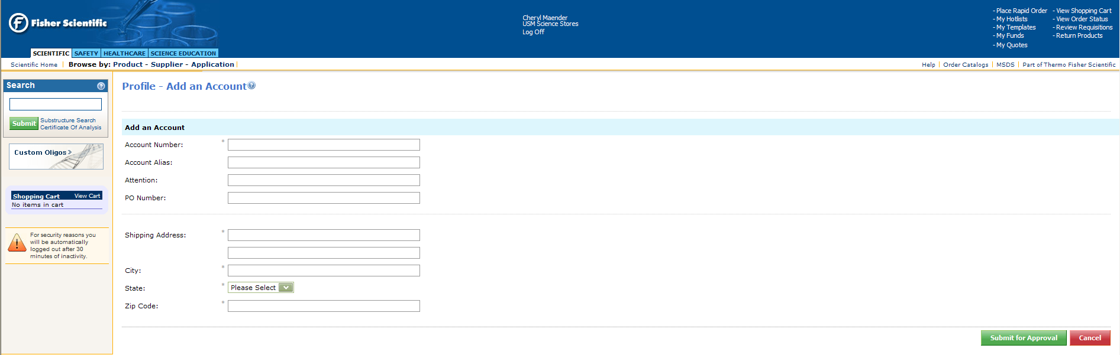

To view or order Storeroom Items
Click on My Hotlists

The Company Hotlist contains the Storeroom items by commodity
This is where you would also create a name for your Personal Hotlist and access them
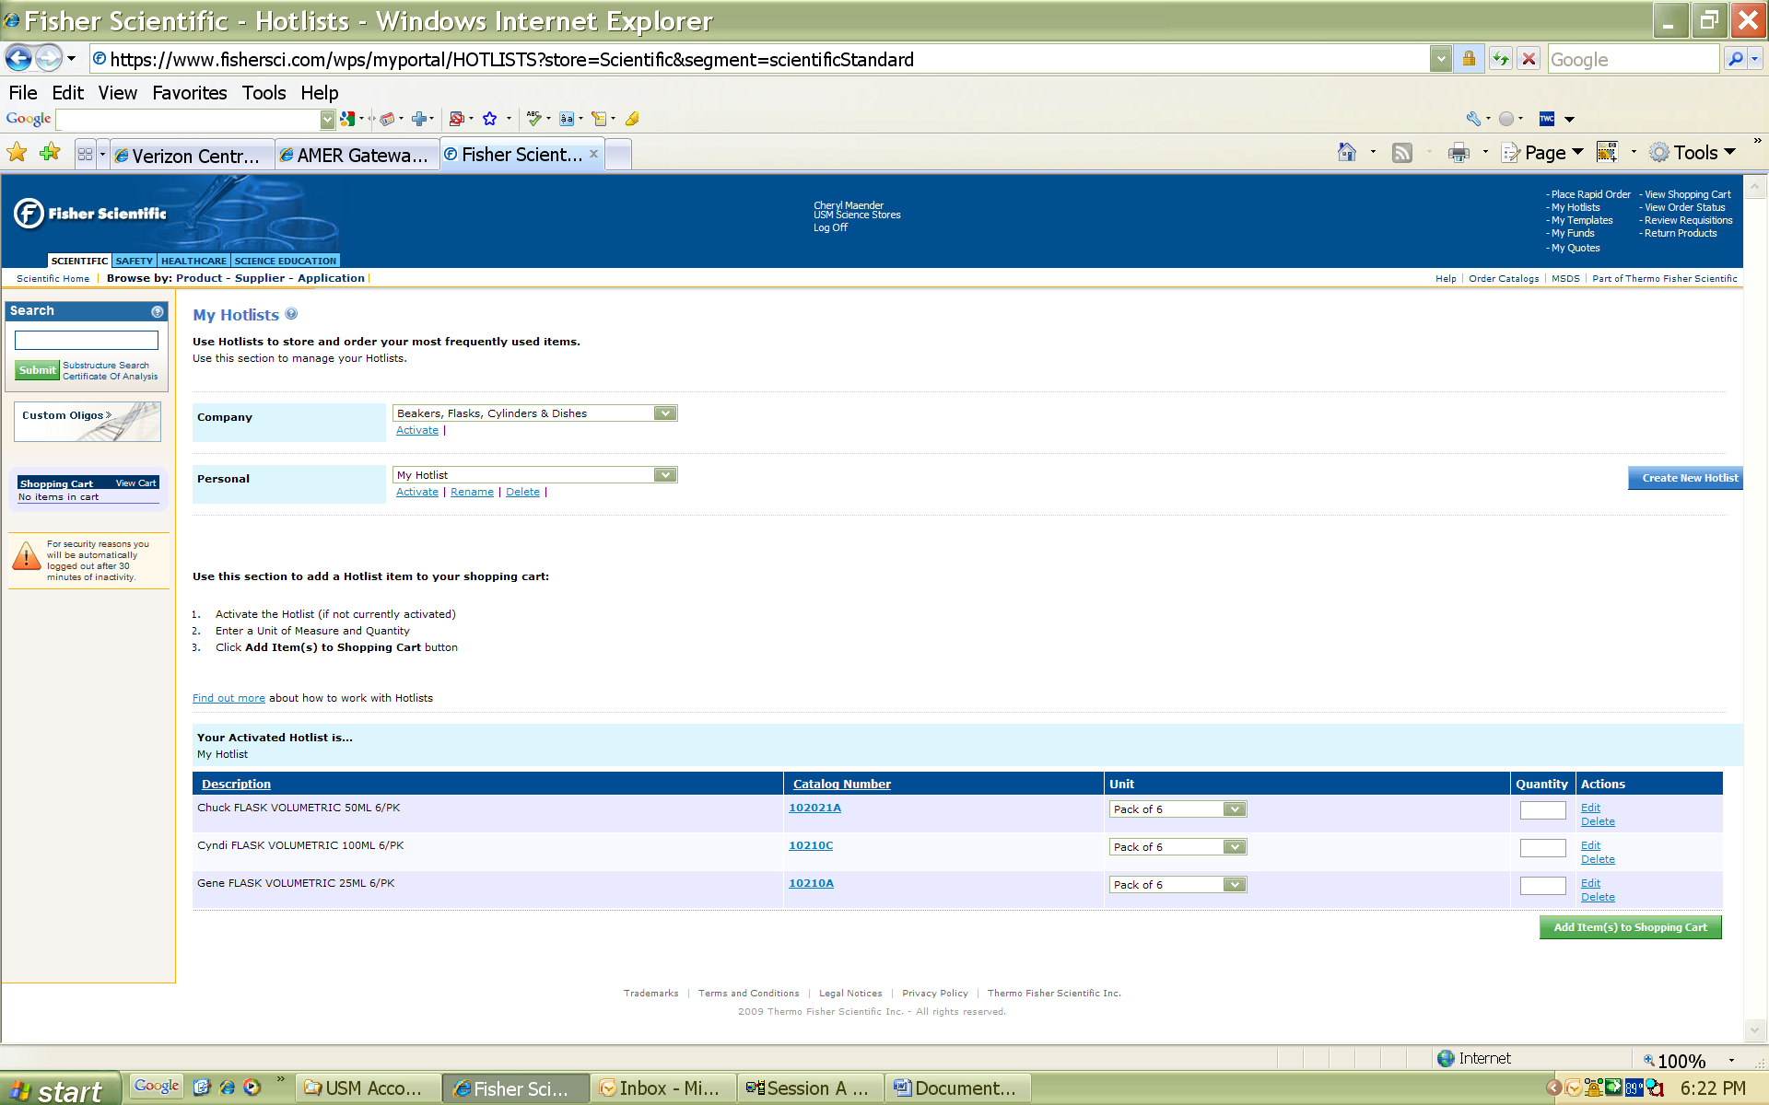

Use the drop down box to access the commodity
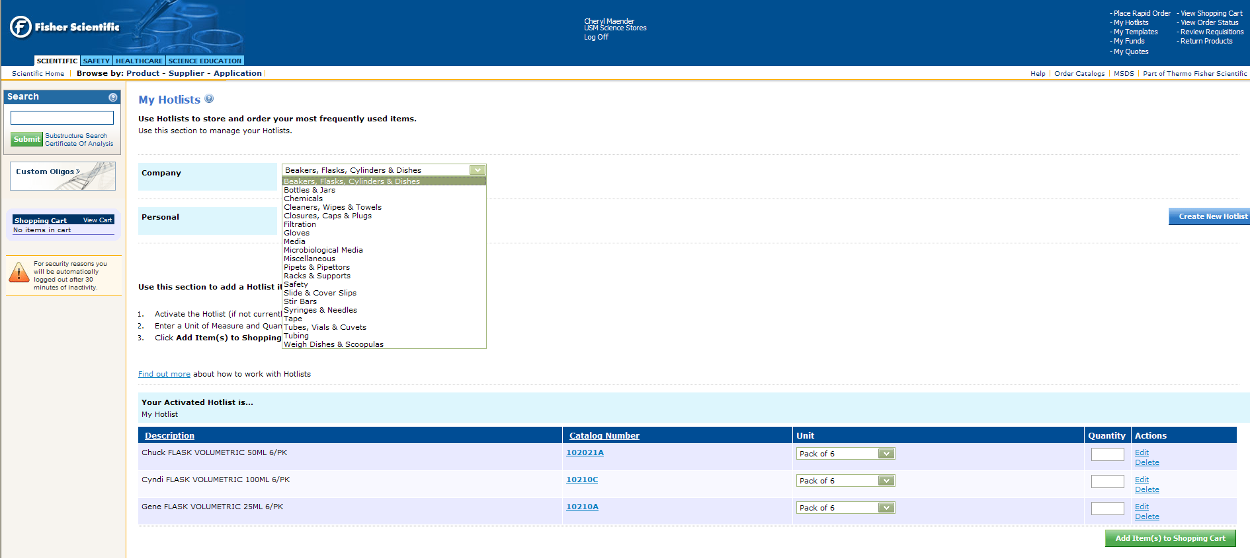
Then click on Activate

When items have been added to the Shopping Cart you will then see the items sourced for the USM Science Storeroom and the items sourced from the Fisher Distribution Center.
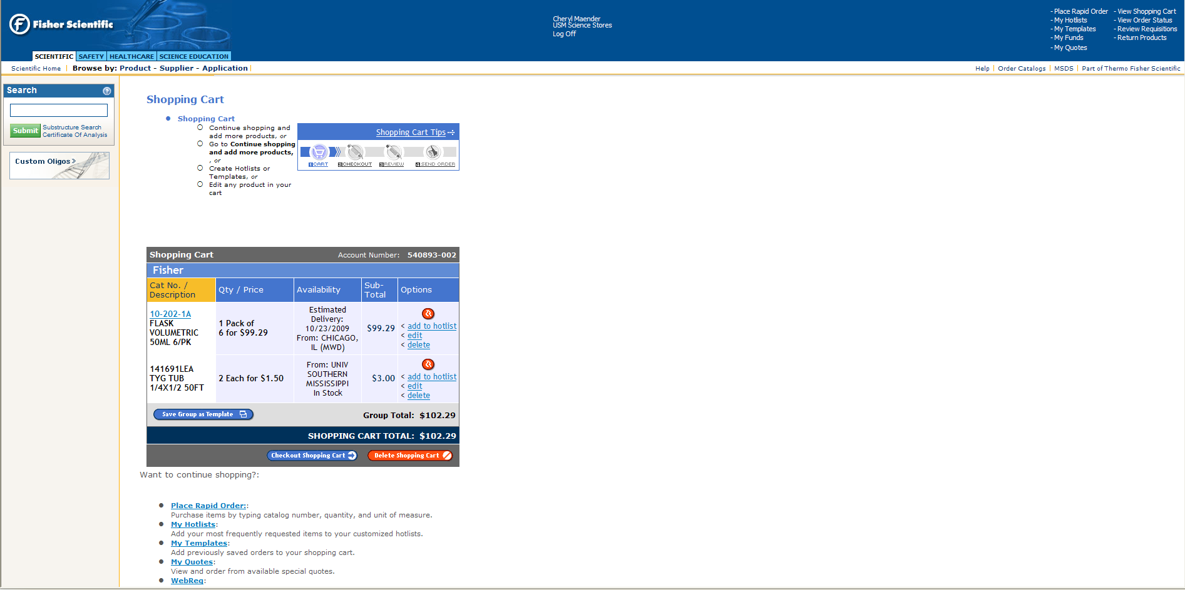

During the Check Out Process, you will be given the choice to bill your account which will result in the order being billed against your Chart String and uploaded weekly into SoarFin or to use your credit card.
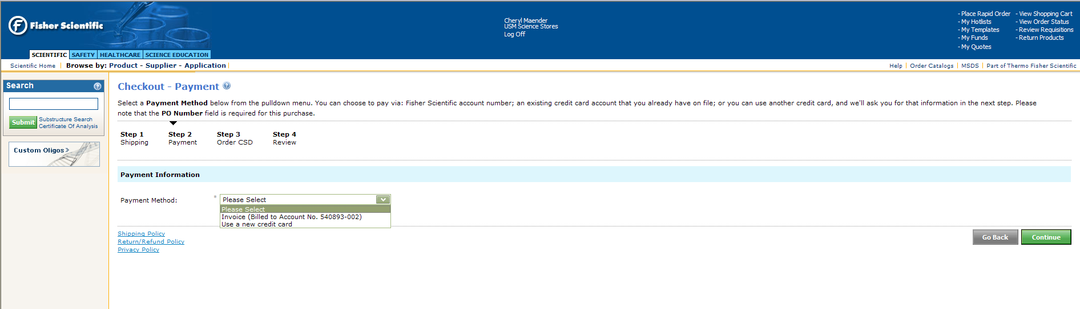
The purchase order is a required field in the Fisher systems. You may choose your purchase order, suggest last name and date. This is not a USM requirement and does not require a SoarFin purchase order.
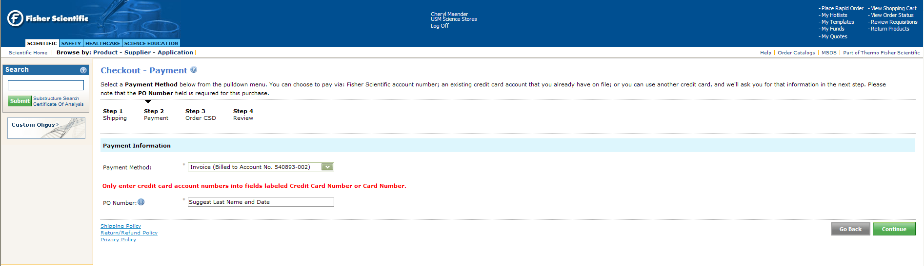

The following information will be required to complete the Check Out process.
Your USM Fund
Your USM Department
Your USM Program Code
Not all purchases will be charged against a Grant/Project ID, so this is an optional field

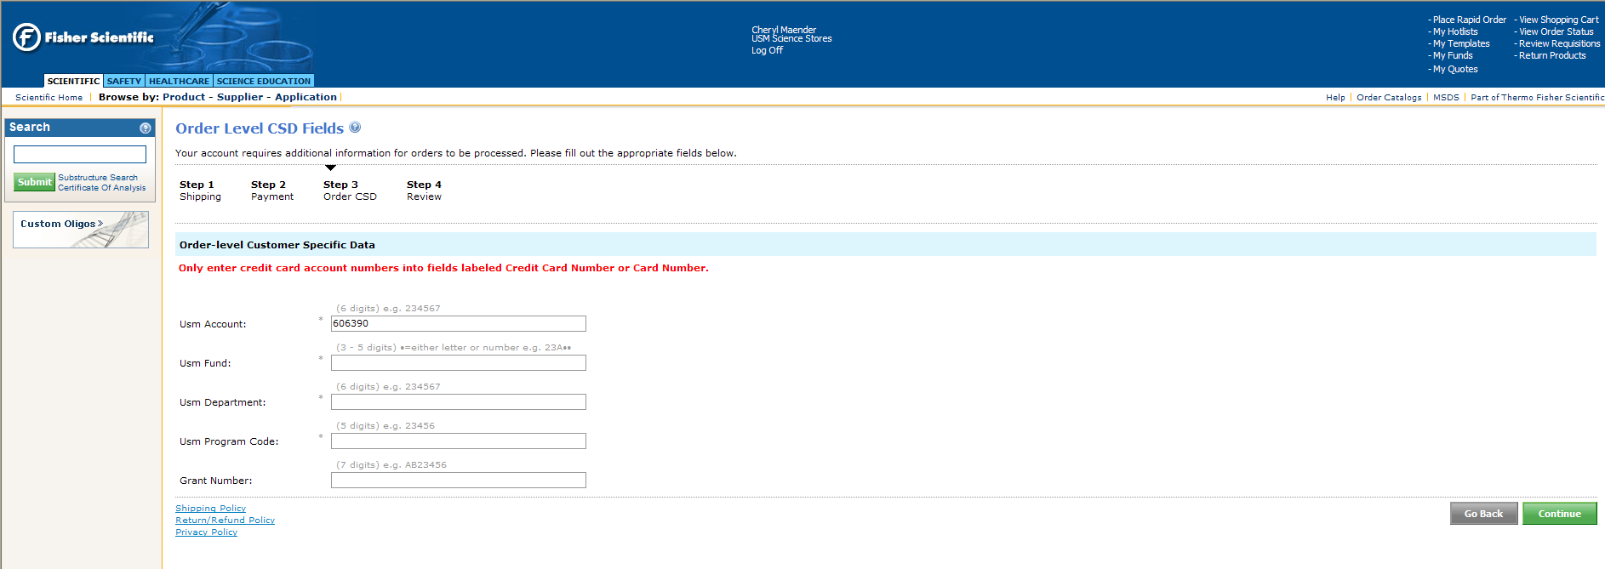

Continue will complete the ordering process as you are accustomed to on the Fisher website.

