For Faculty: Printing Course Evaluations

Step 1: SOAR 9.2 Navigation

- Click on the compass icon in the upper right corner of the screen.

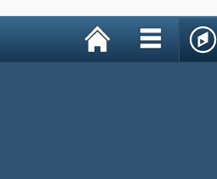

- Select Navigator 
- Select Self Service
- Select USM Self Service
- Select SS
- Select Print Course Evaluations

Self Service > USM Self Service > SS > Print Course Evaluations

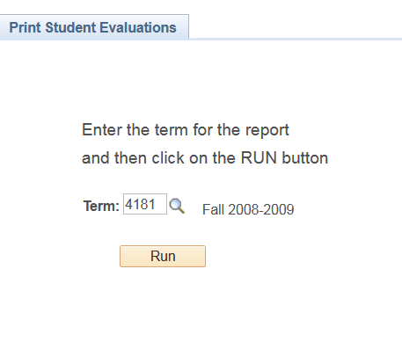

Step 2:
Enter a term code. If you do not know the term code, click on the magnifying glass beside the box and a list of term codes will appear. For example, the term code for Spring 2007 is 4075, Summer 2007 is 4078, and Fall 2007 is 4081.

If you do not see the term listed or you get a message that the term is not available, then the window for instructors to print their evaluations for that term is not open yet.

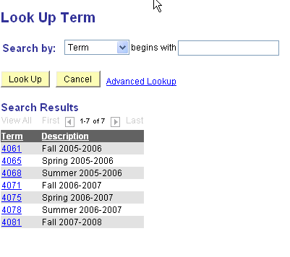
Step 3:
After you enter a term into the box, click the button.

A “Please Wait” message will flash and the panel below will appear. The panel will contain your emplid and the process you just ran.

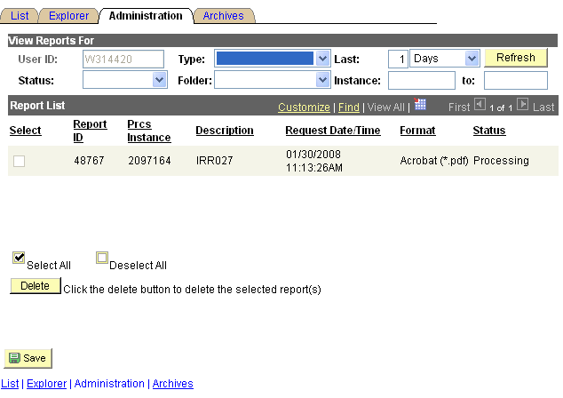

Step 4:
If the Status says Processing just as the screen above indicates, click the button about every 60 seconds until the Status changes to Posted.

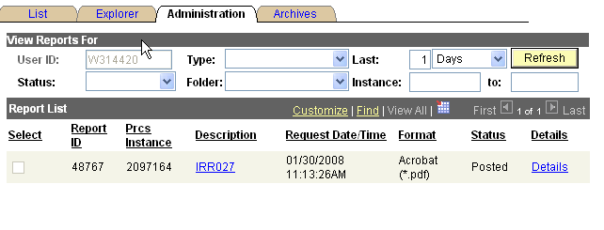

Step 5:
Click on the link. A Report Details panel will appear. Your report is the .pdf link located in the middle of the panel. Open the pdf document and print. You will need the acrobat reader software to open the document. Download the acrobat reader from the links below if you need it.

Acrobat Reader Software

For windows

http://www.adobe.com/products/acrobat/readstep2.html

For Apple/Mac computers

http://www.adobe.com/support/downloads/product.jsp?platform=macintosh&product=10

Institutional Research
601-266-6698

